**GIS and Tourism**

Kristina Ghahramanyan

American University of Armenia

CSE 145 Geographic Information Systems

Aghavni Harutyunyan

October 29, 2020

**1. Introduction**

Tourism can be simply described as a process where people visit and explore different geographical locations. Those travels are often conducted by adventurous individuals in pursuit of spending relaxing time outside their homes. However, nowadays, we have more and more entrepreneurs or employees who use traveling exclusively for business matters. Accordingly, we have two completely different types of travelers. Still, both of them share a significant characteristic: all tourists boost the economy of the visited places by paying for goods and services. Currently, we have a considerable number of regions for which the tourism industry has become their primary source of income. The use of GIS can be applied as an improvement technique for many different branches of our lives, and tourism is undoubtedly one of them. First, we can view GIS as a supportive application for expanding the profits from the tourism industry anywhere. For instance, we know that tourists who visit foreign countries often need a map to navigate an unknown place. With GIS, we can create user-friendly maps that would include the most famous and fascinating locations of an area. Those can contain attractions, museums, amusement parks, etc. By making such maps, tourists will benefit from knowing the best places where they can spend their time. On the other hand, the governments will receive more money from those tourists because those mapped locations will have more customers to pay for their services.

**2. Problem Description**

Additionally, GIS can be helpful not only in assisting the development of tourism but also in preventing some harmful consequences of that industry. Nowadays, tourism has become a threat to local resources, cultural sites and natural habitats. First of all, tourists consume an incredible amount of resources and produce vast amounts of waste. Overconsumption often leads to difficulties such as water shortages and the overuse of local land. Afterward comes the overproduction of waste, which brings another significant danger to communities: pollution. Besides those dangers, countries must also be cautious about preserving their local cultural areas and natural territories open to tourists. Occasionally visitors harm historical memorials or landmarks. An example of such actions could stretch from simple vandalism to the destruction of plant species on the verge of extinction.

**3. GIS Solutions**

Currently, many green sites are suffering from the activities of foreign tourists. A great example of such a site is China’s Yunnan mountainous area. Due to a large number of visitors, that place has undergone damages like the extinction of plant species. To prevent the mountain from further harm, scientists decided to organize a study to determine which areas should have restricted access. The study was conducted using GIS.

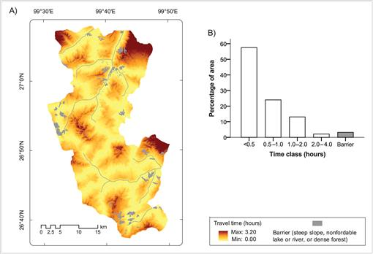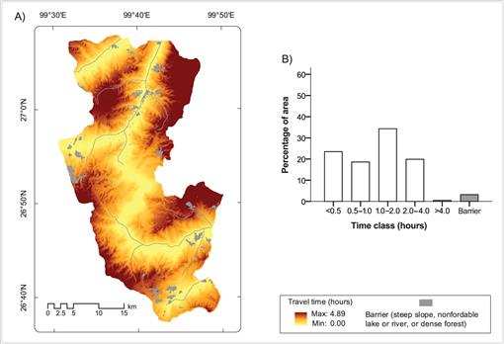In this first map, where people do not have any artificial restrictions, we can see that the tourists are exploring more than half of the area. Also, we can see the little time it takes them to reach the desired location. Based on this map, scientists assumed that the fewer time people need to get to their destinations, the more time they will spend there. Hence, the probability of damaging plants is likely.

In the second map, some restrictions have been added to the area. In this scenario, we see two improvements. People no longer have access to more than half of the mountain, and due to that, they spend more time getting to their destinations. Therefore, the more time on the road leaves them with less time for damaging the plant life.

Now, the local government will be able to protect the vulnerable plant species from extinction. This research shows us the importance of monitoring locations of tourist attractions and the significant role that GIS plays in it.

**4. Conclusion**

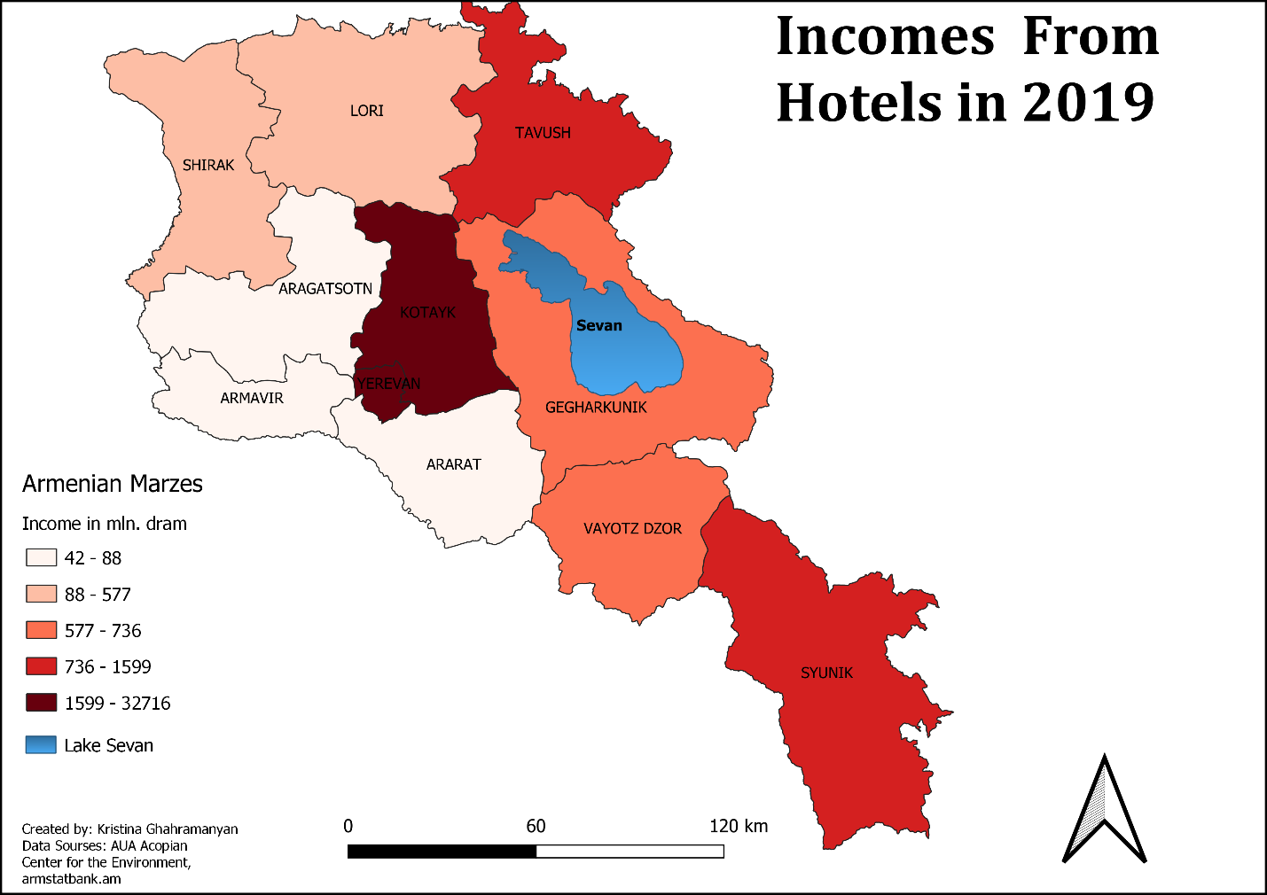Today, here in Armenia, we are facing an enormous issue regarding the high level of pollution in our largest lake Sevan. The contamination is mainly connected to factors like yearly algae bloom and human activities. Those reasons have been affecting our lake for decades, and if we want to preserve some remaining part of it, we need to act now. Many different actions need to happen, but the most important one is minimizing the trash and waste thrown in Sevan. In my opinion, we can try solving this issue by using GIS. For example, I believe that Sevan is one of the most visited places by tourists in Armenia. To prove my point, we can take a look at the map below.

The map represents the incomes of hotels, by Marzes. Marz Gegharkunik, where Sevan is located, made approximately 600 million drams in 2019. The number indicates that this place is quite successful in the tourism industry. Hence, Sevan is visited by thousands of tourists each year. From this information, we can say that tourism can be one of the problems concerning Sevan's waste levels. To fix this issue, I want to suggest a couple of solutions achievable through GIS. First, of course, officials can hire a massive group of people, who would patrol the entire shore of Sevan; however, that would be too expensive. We can lessen the number of people by analyzing daily satellite images in GIS to determine which particular shores are getting the most waste. After the analysis, we will find some areas with no human activity, and we would know that the location does not require protection. Another way to save our lake is to move tourists' attention from Sevan to somewhere else. That step would stabilize the number of tourists in Gegharkunik and redirect it to another place.

For instance, we can use this opportunity to promote other fascinating locations in Armenia. To achieve this, we can use GIS to create functional and beautiful maps for our tourists. In Yerevan, we have tourist guide booths for people to get paper maps, but those are not good enough. We can create unique and high-quality interactable maps in GIS. Moreover, we can make it more modern by letting tourists scan codes for specific maps to make them appear on their phones. Those maps can include places that are currently not promoted enough to interest the foreigners. And to find out which areas require an economic boost from the tourism industry, we can go back to the income map. A great example can be Marz Aragatsotn. With many different adventure tours, it is an excellent place for hiking enthusiasts. Moreover, Byurakan village is located in Aragatsotn, which is home to our Observatory. GIS can support us in generating great maps to make tourists aware of those locations. We can make them colorful and full of unique symbols or add short descriptions to interest people. Nonetheless, right now, most tourists are either unaware of Byurakan or do not stay there for more than a day. If we can expand our tourism industry throughout our whole country, we would benefit in many ways.

**References**

1. Esri Events. (2020, June 19). *Geodesign for Tourism*. [Video]. Retrieved from YouTube: <https://www.youtube.com/watch?v=099IW-wKwW4>

2. Mingyu Yang, Frieke van Coillie, Min Liu, Robert de Wulf, Luc Hens, Xiaokun Ou. (2014, May 1). *A GIS Approach to Estimating Tourists' Off-road Use in a Mountainous Protected Area of Northwest Yunnan, China*. Retrieved from: <https://bioone.org/journals/mountain-research-and-development/volume-34/issue-2/MRD-JOURNAL-D-13-00041.1/A-GIS-Approach-to-Estimating-Tourists-Off-road-Use-in/10.1659/MRD-JOURNAL-D-13-00041.1.full>

3. Statistical Committee of the Republic of Armenia. (retrieved data of 2019). *Tourism data.* Retrieved from: <https://armstatbank.am/pxweb/en/ArmStatBank/ArmStatBank__4%20Transport%20and%20tourism__42%20Tourism/TT-tu-1-2019.px/?rxid=602c2fcf-531f-4ed9-b9ad-42a1c546a1b6,602c2fcf-531f-4ed9-b9ad-42a1c546a1b6>

4. Environmental impacts of tourism. (2001). *Three main impact areas: natural resources, pollution, and physical impacts.* Retrieved from: <http://www.gdrc.org/uem/eco-tour/envi/index.html>